DESCRIPTION
Document shows the relative orientations and locations of the UAV frame, Applanix AX-15, GoPro Cameras, and GPS Antenna.

COORDINATE SYSTEMS
The X-8 system has six different coordinate systems: UAV, AX-15, and one for each GoPro Camera (Down, Front, Back, Side). Images below specify and label axes of each. Exact location of each coordinate system origin will be discussed in the Estimation Methodology section.
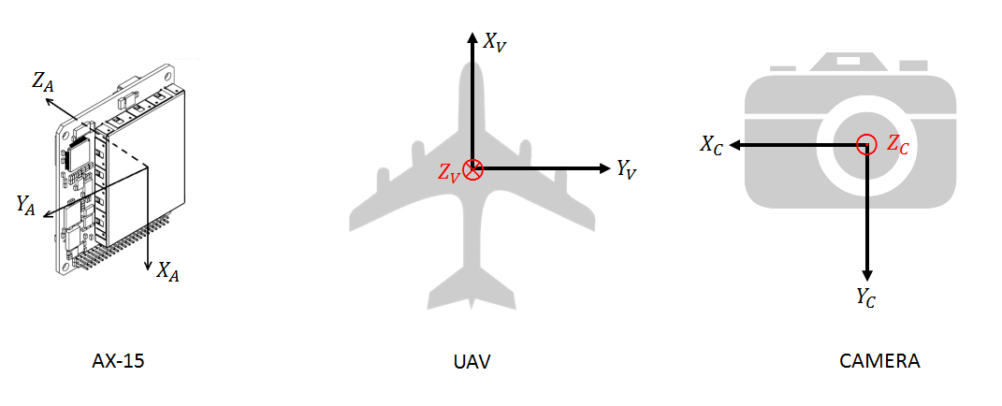

APPLANIX POSPac SPECIFICATIONS
PosPac asks for the following values to perform coordinate rotations and translations. The Reference Frame below refers to the coordinate system of the sensor, i.e. the camera. Because we have more than one camera and thus Reference Frame, we will set the Reference Frame as equivalent to the Vehicle Frame and perform the rotations for each camera outside of PosPac. Thus the output of PosPac is in the UAV Reference Frame.
Reference to IMU (AX-15) Lever Arm- the distance from the Reference Frame origin to the AX-15 Frame origin. Provide XYZ displacement in the Reference Body Frame.
Reference to GNSS Lever Arm- the distance from the Reference Frame origin to the phase center of the GPS Antenna. Provide XYZ displacement in the UAV Body Frame.
Reference to IMU (AX-15) Mounting Angles
Reference to Vehicle (UAV) Mounting Angles

ROTATION CONVENTIONS
The AX-15 and PosPac software requires users to input mounting angles as a Tait-Bryan (TB) series of rotations. Thus all relative orientations will be expressed this way. The TB rotations are defined as the following:
The rotation angles $ϕ,θ,ψ$ are positive counter clockwise when looking into the positive $X,Y,Z$ axis respectively.
The sequence to go from coordinate system B to A is the following:
- Rotate Axis $Z_{A}$ until Axis $Y_{A}$ is in the ${YZ}_{B}$ plane ($ϕ).$
- Rotate Axis $Y_{A}$ until $X_{A}$ matches or is parallel to $X_{B}$ ($θ)$.
- Rotate Axis $X_{A}$ until $Y_{A}$ matches $Y_{B}$ (and all others axes match as well,$ψ$).
and the associated rotation matrix $R_{B→A}$ is
$$R_{B→A}=R_{z}R_{y}R_{x}$$

$$R_{z}=\left[\begin{matrix}cosϕ & -sinϕ & 0 \\ sinϕ & cosϕ & 0 \\ 0 & 0 & 1\end{matrix}\right]{ R}_{y}=\left[\begin{matrix}cosθ & 0 & sinθ \\ 0 & 1 & 0 \\ -sinθ & 0 & cosθ\end{matrix}\right] { R}_{x}=\left[\begin{matrix}1 & 0 & 0 \\ 0 & cosψ & -sinψ \\ 0 & sinψ & cosψ\end{matrix}\right]$$

ESTIMATION METHODOLOGY
Angles and distances were estimated using a CAD model of the X8 UAV Frame, AX-15, and Camera housing. While dimensions and relative positions of the AX-15 and camera housing could be easily incorporated into the CAD program, the X8-Frame was modeled from scratch using dimensions measured by hand. Thus, there could errors associated with this measurement on the order of millimeters.
In addition, the model assumes surfaces of the camera housing were installed perfectly flush and center to the UAV frame. To account for this, vehicle roll, pitch, and azimuth values were recorded by the AX-15 when the assembled UAV system was stationary on a level surface. Non-zero angles ($Δϕ,Δθ,Δψ$) were taken and added to the Reference to IMU (AX-15) Mounting Angles values to account for this assumption error. The origin of the UAV frame lies on the longitudinal centerlines of the bottom plate, on bottom of the plate. It is centered between two holes used for mounting the camera housing. Each GoPro camera origin is taken at the focal point of the camera.

VALUES
 | X (m) or $ϕ$ [º] | Y (m) or $θ$ [º] | Z (m) or $ψ$ [º]
Reference to IMU (AX-15) Lever Arm | -0.030 | 0.055 | 0.062
Reference to GNSS Lever Arm | 0.130 | 0 | -.024
Reference to IMU (AX-15) Mounting Angles | 0+$Δϕ$ | 180+$Δθ$ | -90+$Δψ$
Reference to Vehicle (UAV) Mounting Angles | 0 | 0 | 0
* $Δϕ,Δθ, Δψ$ is estimated to be 1,-1, and 0 respectively
 | X (m) or $ϕ$ [º] | Y (m) or $θ$ [º] | Z (m) or $ψ$ [º]
UAV to Down Camera Lever Arm $(T)$ | -0.041 | -0.027 | 0.112
UAV to Down Camera Angles | 0+$Δϕ$ | 0+$Δθ$ | 90-$Δψ$
UAV to Side Camera Lever Arm $(T)$ | -0.045 | 0.091 | 0.094
UAV to Side Camera Angles | 40+$Δϕ$ | 0+$Δθ$ | 0-$Δψ$
UAV to Front Camera Lever Arm $(T)$ | 0.039 | 0.023 | 0.072
UAV to Front Camera Angles | 0+$Δϕ$ | -55+$Δθ$ | 180-$Δψ$
UAV to Back Camera Lever Arm $(T)$ | -0.084 | 0.024 | 0.093
UAV to Back Camera Angles | 0+$Δϕ$ | 55+$Δθ$ | 180-$Δψ$
* UAV to Camera Lever Arms measured in the UAV Coordinate system.

TRANSFORMATION MATRICES
The Smoothed Best Estimate Trajectory (SBET) output by the PosPac software expresses angles and position in the global coordinate system (East, North, Up/Down, Roll, Pitch, and Azimuth). To produce time series of camera orientation and position in the global coordinate system, the following transformation is carried out for each camera.
To determine the position of each camera origin in global coordinates ($E_{C-}, N_{C-}, G_{C-}$), first the UAV to Camera Lever Arm coordinates are placed in the position vector $T_{-}$ (- is the initial of the individual camera, D,S,F, or B). $T_{-}$ is then multiplied by the Rotation Matrix $R_{UAV→Global}$ defined by the TB intrinsic rotations for a UAV to Global rotation. Finally these camera positions are added on to the SBET position output, $E_{UAV}, N_{UAV}, G_{UAV}$.

$$\left[\begin{matrix}E_{C-} \\ N_{C-} \\ G_{C-}\end{matrix}\right]={\left[\begin{matrix}E_{UAV} \\ N_{UAV} \\ G_{UAV}\end{matrix}\right]+R}_{UAV→Global}T_{-}=\left[\begin{matrix}E_{UAV} \\ N_{UAV} \\ G_{UAV}\end{matrix}\right]+R_{UAV→Global}\left[\begin{matrix}X_{C-} \\ Y_{C-} \\ Z_{C-}\end{matrix}\right]$$

So the rotation matrix $R_{UAV→Global}$ is defined by
UAV to Global Coordinate TB Rotations
 | $$ψ$$ | $$θ$$ | $$ϕ$$
$$γ$$ | $$-α$$ | $$180-β$$ | $$-90-γ$$

where $α,β,γ$ are roll, pitch, and azimuth of the UAV respectively as output by PosPac.
Also, for future analysis, the rotation matrix $R_{UAV→C}$ is defined by the Tait Bryan UAV to Camera Angles provided in the table above. Thus the Rotation matrix from Global Coordinates to Camera Coordinates is given by
$${R_{Global→C}=}_{}{R_{UAV→Global}}^{-1}*R_{UAV→C}$$

