BathyDuck Argus Data Collections  
Coastal Imaging Lab

Oregon State University

September – October, 2015

**CIL bathyDuck Collections**

Regular, ongoing Argus collections were supplemented during bathyDuck in support of other investigators as well as our own research. This document describes the Argus collection system and the data collected as well as how and where to access the data.

**Argus Cameras**

The Argus cameras are located in the FRF tower at roughly xyz = [33, 584, 43] in FRF coordinates. Previous cameras installed in 1997 were replaced on February 19, 2015 to higher resolution versions (2448 by 2048 pixels) and the camera numbering system was changed to a less impenetrable version. This Argus station goes by the name Argus02b in the archiving structure described herein. We now use six cameras, oriented in order from alongshore north to alongshore south.

Images can either be used individually or as merged products such as below (boundaries between cameras are visible due to camera white balance differences and are marked with dashed lines to aid the eye).



Figure 1. Merged snapshot showing the fields of view of the five primary cameras.

Cameras geometry control is maintained using a set of ground control points (GCPs) whose locations are known. Geometries were established soon after installation with an update to C1 on approximately 09/24 to correct a small camera shift. Camera resolution varies from approximately 10 cm immediately seaward of the tower to 0.5 m or more (in the range direction) at the FRF property boundaries (see Figure below). Time is synched to the FRF NTP server continuously.

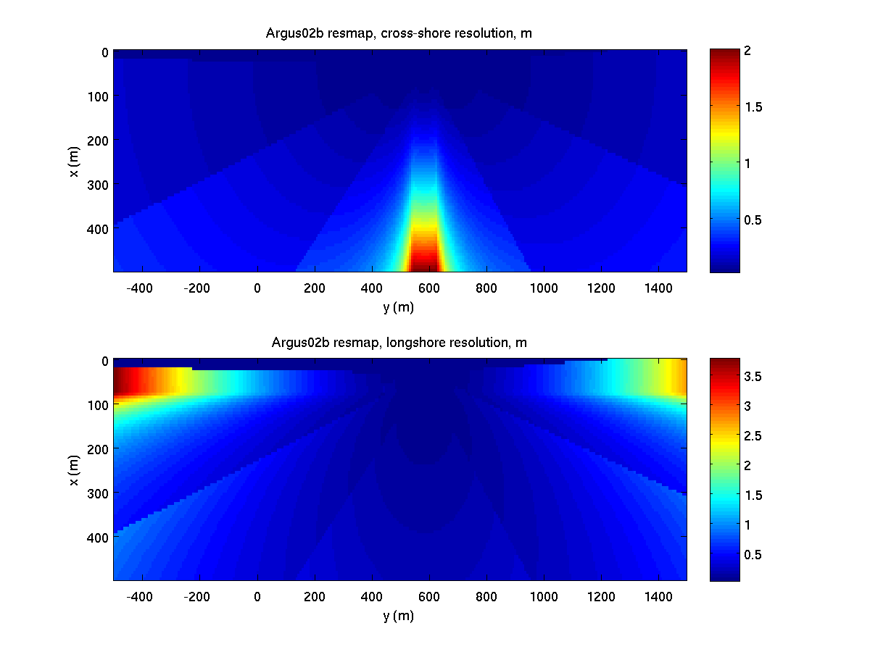

Figure 2. Resolution maps in terms of cross-shore and longshore.

**Data Locations and Naming Conventions**

Data are stored both at the CIL and at the FRF. I’m unclear how the FRF storage works but will describe the CIL strategy.

Data are stored on the CIL ftp site, cil-ftp.coas.oregonstate.edu and can be downloaded using normal anonymous ftp (with a valid RFC822 format email address as the password). Duck data is sorted by site/year/camera/day/file. For example, images for C2 of March 2, 2015 would be located in /ftp/pub/argus02b/2015/c2/062_Mar.02.

Argus filenames using a long (and useful) naming convention. For example:

1425294001.Mon.Mar.02_11_00_01.GMT.2015.argus02b.c1.timex.jpg

is a time exposure images for C1 collected on March 2, 2015 at 11:00:01 GMT. All Argus data are saved in GMT (because we have stations in many time zones). Note that images also have timestamp and other information imprinted on the top and bottom borders. These are written in local standard time (note that merged images stored as camera “Cx” are only listed in GMT time – more on Cx below). Be careful to not confuse these (image stamp in EST, filename in GMT = EST+5). Our primary time reference is epoch time, a computer standard that is the number of seconds since January 1, 1970 (GMT). This is the 10-digit leading number in the filename. Routines to convert between epoch to matlab’s datenum are located in /ftp/pub/Experiments/SZO2010/commonMatlabCode.

Six types of images are collected:

* Snapshot
* Timex – average of 2Hz frames collected over ten-minute period
* Var – standard deviation of same image sample
* Bright – brightest that each pixel gets over the same period
* Dark - darkest that each pixel gets over the same period
* Rundark - darkest computing using a running average algorithm to suppress noise

In addition, daytimex images average all of the timex images for a day.

Merged images like Figure 1, are automatically processed and are stored as camera Cx using the same naming conventions but with an additional suffix ‘merge’. For example,

1432908003.Fri.May.29_14_00_03.GMT.2015.argus02b.cx.bright.merge.png

is a merged brightest image from May 29 at 14:00:-3 GMT (~0900 EST or 1000 EDT). These are stored as png images. Note that the merged image data are also stored as .mat files so you can create your own figures, for example using

‘imagesc(y,x,I)’.

**Pixel Time Series**

While image data synthesize data from a 10-minute collect into single images, pixel time series data sample and save the 2Hz time variability for 2048 samples (17+ minutes), but only for specific requested pixels. Data are generally called time stacks and files are saved under each camera as raster files with the suffix ‘.stack.ras’ (usually gzip compressed, so with an additional .gz suffix). Retrieval of data is somewhat complicated, but has been automated since 2010 and results are stored under Cx. For example, the file

1432909740.Fri.May.29_14_29_00.GMT.2015.argus02b.cx.cBathy.mat

is a matlab data file from September May 29 that contains the cBathy computation results (see the cBathy user manual for a full description of this matlab structure.

On a more primitive level, the file

1432909740.Fri.May.29_14_29_00.GMT.2015.argus02b.cx.runup750.mat

contains pixel time series data for a cross-shore runup stack located at y~950 m, while

1432909740.Fri.May.29_14_29_00.GMT.2015.argus02b.cx.vbar150.mat

is a stack file for a vBar data collection (used for longshore currents) at x ~ 150 m.

All pixel instrument mat files contain the following variables

* T - epoch time for each of the N samples in the time series
* XYZ - FRF locations for each of the M pixels (z usually =0)
* RAW - N by M time stack of raw camera intensities
* CAM - camera number associated with each pixel (length M)
* GAIN - N gain values (for each frame) (usually constant for run)
* SHUTTER - N shutter exposure times
* CORRECTED - image brightness corrected for gain and shutter.

Corrected intensities are RAW divided by 10^(gain/20) * shutter, reversing the camera compensation for changing lighting conditions during the day.

The following instruments are routinely being collected:

* mBW - cBathy pixel array, x = [80:5:800]; y = [0:10:1000];
* runupxxx - runup lines from x = 0:160, y = 650:50:1100 plus y = 945;
* vbarxxx - linear longshore arrays at x=xxx m, y = 0:1500
* cBathy - cBathy solutions (not an instrument

Other instruments can be added as needed. Contact Rob Holman.

**Collection Schedules**

Argus collections are usually hourly but were supplemented for SZO2010. For each daylight hour, collections were as follows:

Minute after hour Collection

00, 30 image products (snap, timex, etc)

59, 29 all pixel instruments

The collection clock is synched continuously with the FRF NTP time server. All collections should start at the top of the minute, but make have order ½ second delays. However, epoch times will always be correct.

**Matlab Files**

Several useful matlab files are located on /ftp/pub/Experiments/SZO2010/commonMatlabCode. These include epoch to matlab conversion and a short example routine to load and use an instrument.

Problems:

Contact Rob Holman, [holman@coas.oregonstate.edu](mailto:holman@coas.oregonstate.edu).